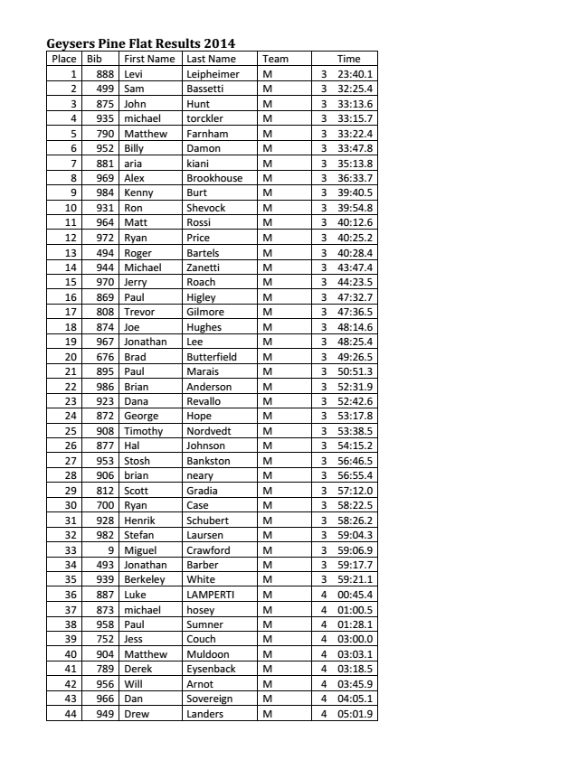
Geysers Pine Flat Results 2014
Place Bib First Name Last Name Team Time
1 888 Levi Leipheimer M 3 23:40.1 2 499 Sam Bassetti M 3 32:25.4 3 875 John Hunt M 3 33:13.6 4 935 michael torckler M 3 33:15.7 5 790 Matthew Farnham M 3 33:22.4 6 952 Billy Damon M 3 33:47.8 7 881 aria kiani M 3 35:13.8 8 969 Alex Brookhouse M 3 36:33.7 9 984 Kenny Burt M 3 39:40.5 10 931 Ron Shevock M 3 39:54.8 11 964 Matt Rossi M 3 40:12.6 12 972 Ryan Price M 3 40:25.2 13 494 Roger Bartels M 3 40:28.4 14 944 Michael Zanetti M 3 43:47.4 15 970 Jerry Roach M 3 44:23.5 16 869 Paul Higley M 3 47:32.7 17 808 Trevor Gilmore M 3 47:36.5 18 874 Joe Hughes M 3 48:14.6 19 967 Jonathan Lee M 3 48:25.4 20 676 Brad Butterfield M 3 49:26.5 21 895 Paul Marais M 3 50:51.3 22 986 Brian Anderson M 3 52:31.9 23 923 Dana Revallo M 3 52:42.6 24 872 George Hope M 3 53:17.8 25 908 Timothy Nordvedt M 3 53:38.5 26 877 Hal Johnson M 3 54:15.2 27 953 Stosh Bankston M 3 56:46.5 28 906 brian neary M 3 56:55.4 29 812 Scott Gradia M 3 57:12.0 30 700 Ryan Case M 3 58:22.5 31 928 Henrik Schubert M 3 58:26.2 32 982 Stefan Laursen M 3 59:04.3 33 9 Miguel Crawford M 3 59:06.9 34 493 Jonathan Barber M 3 59:17.7 35 939 Berkeley White M 3 59:21.1 36 887 Luke LAMPERTI M 4 00:45.4 37 873 michael hosey M 4 01:00.5 38 958 Paul Sumner M 4 01:28.1 39 752 Jess Couch M 4 03:00.0 40 904 Matthew Muldoon M 4 03:03.1 41 789 Derek Eysenback M 4 03:18.5 42 956 Will Arnot M 4 03:45.9 43 966 Dan Sovereign M 4 04:05.1 44 949 Drew Landers M 4 05:01.9 45 537 Ario Bigattini M 4 05:08.0

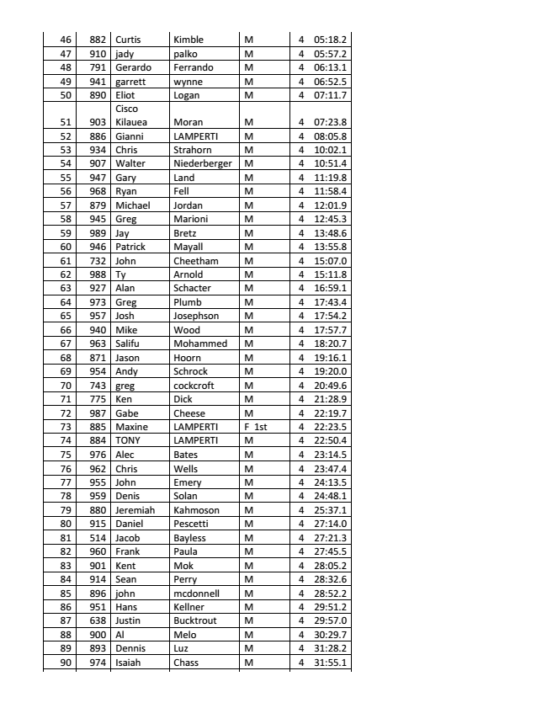
46 882 Curtis Kimble M 4 05:18.2 47 910 jady palko M 4 05:57.2 48 791 Gerardo Ferrando M 4 06:13.1 49 941 garrett wynne M 4 06:52.5 50 890 Eliot Logan M 4 07:11.7
51 903
Cisco Kilauea Moran M 4 07:23.8 52 886 Gianni LAMPERTI M 4 08:05.8 53 934 Chris Strahorn M 4 10:02.1 54 907 Walter Niederberger M 4 10:51.4 55 947 Gary Land M 4 11:19.8 56 968 Ryan Fell M 4 11:58.4 57 879 Michael Jordan M 4 12:01.9 58 945 Greg Marioni M 4 12:45.3 59 989 Jay Bretz M 4 13:48.6 60 946 Patrick Mayall M 4 13:55.8 61 732 John Cheetham M 4 15:07.0 62 988 Ty Arnold M 4 15:11.8 63 927 Alan Schacter M 4 16:59.1 64 973 Greg Plumb M 4 17:43.4 65 957 Josh Josephson M 4 17:54.2 66 940 Mike Wood M 4 17:57.7 67 963 Salifu Mohammed M 4 18:20.7 68 871 Jason Hoorn M 4 19:16.1 69 954 Andy Schrock M 4 19:20.0 70 743 greg cockcroft M 4 20:49.6 71 775 Ken Dick M 4 21:28.9 72 987 Gabe Cheese M 4 22:19.7 73 885 Maxine LAMPERTI F 1st 4 22:23.5 74 884 TONY LAMPERTI M 4 22:50.4 75 976 Alec Bates M 4 23:14.5 76 962 Chris Wells M 4 23:47.4 77 955 John Emery M 4 24:13.5 78 959 Denis Solan M 4 24:48.1 79 880 Jeremiah Kahmoson M 4 25:37.1 80 915 Daniel Pescetti M 4 27:14.0 81 514 Jacob Bayless M 4 27:21.3 82 960 Frank Paula M 4 27:45.5 83 901 Kent Mok M 4 28:05.2 84 914 Sean Perry M 4 28:32.6 85 896 john mcdonnell M 4 28:52.2 86 951 Hans Kellner M 4 29:51.2 87 638 Justin Bucktrout M 4 29:57.0 88 900 Al Melo M 4 30:29.7 89 893 Dennis Luz M 4 31:28.2 90 974 Isaiah Chass M 4 31:55.1 91 917 Robert Picard M 4 34:47.0

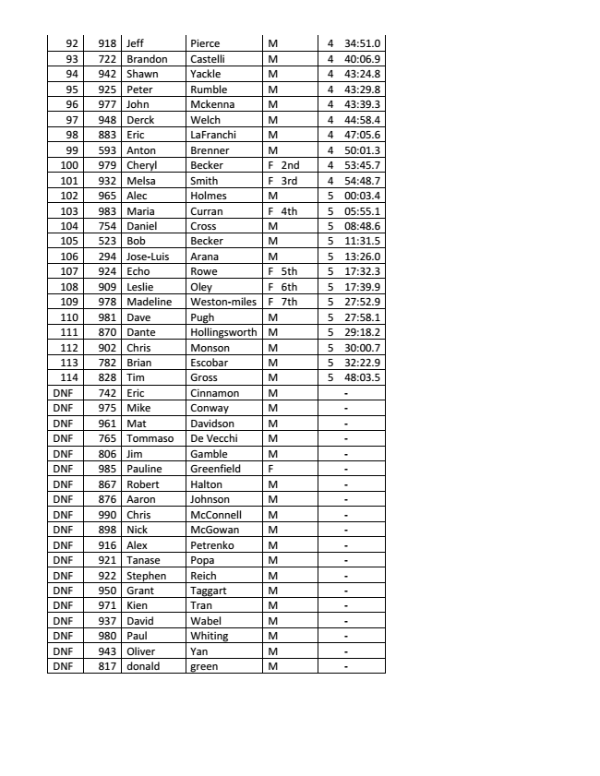
92 918 Jeff Pierce M 4 34:51.0 93 722 Brandon Castelli M 4 40:06.9 94 942 Shawn Yackle M 4 43:24.8 95 925 Peter Rumble M 4 43:29.8 96 977 John Mckenna M 4 43:39.3 97 948 Derck Welch M 4 44:58.4 98 883 Eric LaFranchi M 4 47:05.6 99 593 Anton Brenner M 4 50:01.3 100 979 Cheryl Becker F 2nd 4 53:45.7 101 932 Melsa Smith F 3rd 4 54:48.7 102 965 Alec Holmes M 5 00:03.4 103 983 Maria Curran F 4th 5 05:55.1 104 754 Daniel Cross M 5 08:48.6 105 523 Bob Becker M 5 11:31.5 106 294 Jose-­‐Luis Arana M 5 13:26.0 107 924 Echo Rowe F 5th 5 17:32.3 108 909 Leslie Oley F 6th 5 17:39.9 109 978 Madeline Weston-­‐miles F 7th 5 27:52.9 110 981 Dave Pugh M 5 27:58.1 111 870 Dante Hollingsworth M 5 29:18.2 112 902 Chris Monson M 5 30:00.7 113 782 Brian Escobar M 5 32:22.9 114 828 Tim Gross M 5 48:03.5 DNF 742 Eric Cinnamon M -­‐ DNF 975 Mike Conway M -­‐ DNF 961 Mat Davidson M -­‐ DNF 765 Tommaso De Vecchi M -­‐ DNF 806 Jim Gamble M -­‐ DNF 985 Pauline Greenfield F -­‐ DNF 867 Robert Halton M -­‐ DNF 876 Aaron Johnson M -­‐ DNF 990 Chris McConnell M -­‐ DNF 898 Nick McGowan M -­‐ DNF 916 Alex Petrenko M -­‐ DNF 921 Tanase Popa M -­‐ DNF 922 Stephen Reich M -­‐ DNF 950 Grant Taggart M -­‐ DNF 971 Kien Tran M -­‐ DNF 937 David Wabel M -­‐ DNF 980 Paul Whiting M -­‐ DNF 943 Oliver Yan M -­‐ DNF 817 donald green M -­‐

